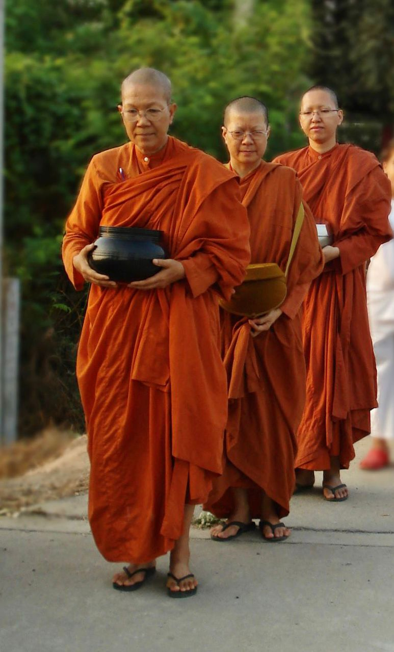
Venerable Dhammananda on Alms Round 2006
Photo by Hansa Piparsania

About Venerable Dhammananda

Venerable Dhammananda Bhikkhuni (pronounced Dhamma-nanda peek-su-ni) is the abbess and spiritual leader of Sondhammakalayni Temple, an all-female monastery in Nakon Pathom, Thailand, located about 56 kilometers west of Bangkok. Venerable Dhammananda was the first Thai woman to receive full ordination in the Theravada Buddhist tradition. Prior to her there were no female monastics in the history of Thailand. Twenty years have passed since Venerable Dhammananda’s ordination and since that time, there are now 270 ordained women in Thailand.

Venerable Dhammananda spent years as an academic researching the original texts to confirm that the Buddha ordained women in his own time. “The Buddha,” she said, “was the first feminist because he was the first religious leader in the world to acknowledge that women and men are equal spiritually. When the Buddha gave permission for women to be ordained in his lifetime, he declared that women can be enlightened. There is no other religion before Buddhism, which so clearly recognized the spiritual potential of women.”

The Buddha not only elevated the status of women by recognizing them as capable of enlightenment, but he also confirmed their participation as ordained members of the fourfold sangha. Near the end of his life, the Buddha spoke about the importance of the fourfold sangha, also known as the fourfold assembly which consists of: bhikkhus (fully ordained Buddhist monks), and bhikkhunis (fully ordained Buddhist nuns), laymen and laywomen. The word Sangha is a Sanskrit and Pali word that means community Venerable Dhammananda explains the situation this way. “You could say in my country that one leg of the chair—the fully ordained nuns—was missing. I needed to bring back this fourth leg.” Venerable Dhammananda has dedicated her life to restoring women their rightful place in Buddhism.

Venerable Dhammananda has always emphasized the importance of the Bhikkhuni Sangha over the individual. It is not enough for a woman to ordain and then lead a solitary practice. She has said that an individual bhikkhuni, regardless of how admirable her practice is, will eventually pass away. A thriving sangha ensures that Buddhism will survive through the ages.

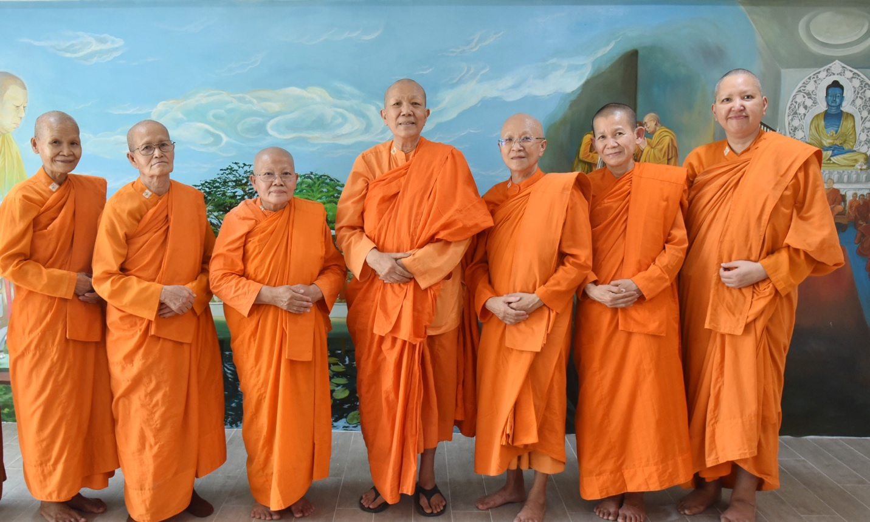

Venerable Dhammananda with her sangha, October 2023. Photographer unknown.

Venerable Dhammananda is a highly engaging speaker, internationally recognized Buddhist scholar, socially engaged feminist, and environmental activist. Her decision to ordain carries great weight, as do her academic and spiritual contributions to the current wave of Buddhist feminist activists in Thailand, especially when one understands the degree to which Thai women have been marginalized by their religion. She explained her decision, saying, “I have traversed the globe so that my grandchildren will be proud of their grandmother who cleared the path for them to walk proudly as Buddhist women.”

Education and Academic Career

Formerly known by her lay name, Dr. Chatsumarn Kabilsingh received her BA in Philosophy from Visva-Bharati University, located in West Bengal, India.

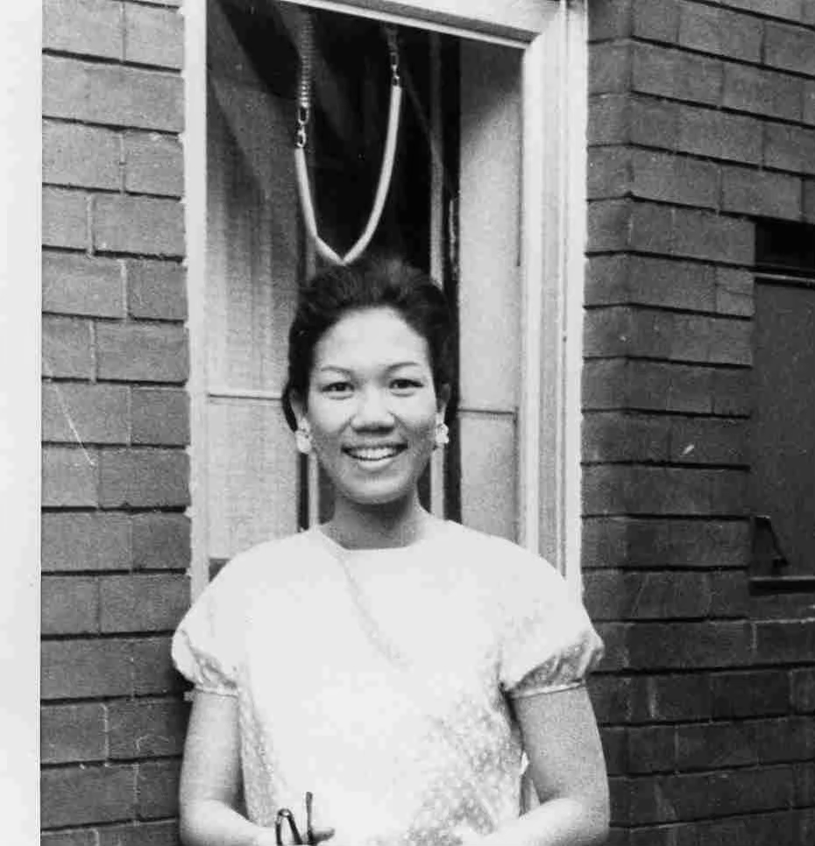

Chatsumarn Kabilsingh, an undergraduate student in India. Photographer unknown

She received her master’s degree in Religion from McMaster University in Ontario, Canada, and her PhD in Buddhism from Magadh University in Bodh Gaya, India. She was a professor of Buddhism and Eastern Philosophy at Thammasat University in Bangkok for twenty-seven years. She has authored more than 100 books, including several written in English. Among her most important works is the first Thai translation of the Lotus Sutra. Her most popular book in English, Thai Women in Buddhism, was published by Parallax Press in 1991 and, most recently, she wrote the foreword for Daughters of the Buddha: Teachings by Ancient Indian Women by Venerable Bhikkhu Analayo published in 2023. She has translated twenty-seven books on Tibetan Buddhism, including Freedom in Exile, H.H. the Dalai Lama.

Ordination

Venerable Dhammananda, did not begin to think seriously about being ordained until her mid-fifties. At that time in her life, she was at the peak of success in her career— a respected professor renowned for her studies on Thai women in Buddhism and a popular TV dharma host. She had been married for thirty years and raised three sons. In 2000, she divorced her husband, resigned her position as professor, and left her three sons, who were by then, fully grown. It was important that she fulfill her role as a mother, first, to raise her sons, before she left home. She is currently a proud grandmother of six grandchildren and has one great grandson.

Venerable Dhammananda’s novice (lower) ordination took place in Sri Lanka on February 6, 2001. She had to travel to Sri Lanka because Thailand does not permit ordination of women. As the first openly ordained Theravadin bhikkhuni, Venerable Dhammananda’s ordination sparked a huge public debate in Thailand. She was attacked in the media and received hate mail. When asked if she was brave, Venerable Dhammananda simply commented, “Actually, I have no bravery. All I have is strong faith in the Buddha.” She proudly asserted, “We are on the right side of history.”
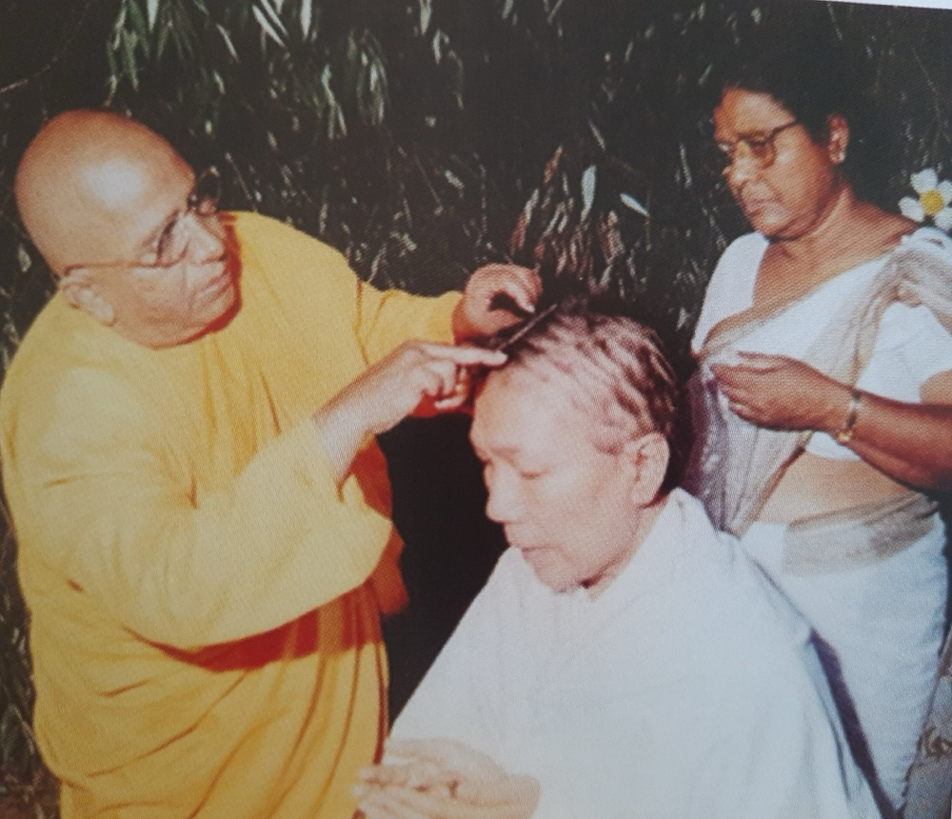
Venerable Dhammananda’s having her head shaved at her lower ordination in Sri Lanka in 2001. Photographer unknown

Venerable Dhammananda received bhikkhuni (higher) ordination in Sri Lanka on February 28, 2003. In 2004 she received the UN Outstanding Buddhist Woman award, and in 2005 she was one of one thousand “Peace Women” to be nominated for a Nobel Peace Prize. She is a wise Buddhist scholar, and a social and environmentalist activist. In November of 2014 she was appointed the first Thai Pavattini (bhikkhuni teacher) by Most Venerable Mahindavamsa Maha Nayaka of the Ampura sect in Sri Lanka. In 2019 the BBC named her to its list of 100 of the most influential women in the world because of her tireless work to re-establish the Theravada female monastic lineage in Asia.

Why Her Voice Matters

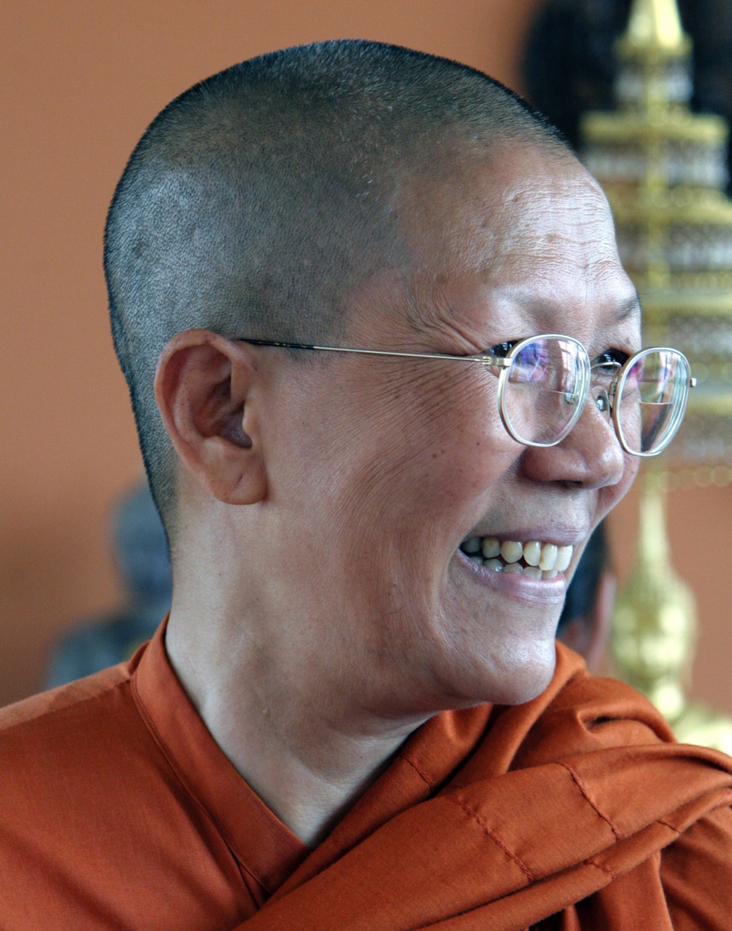

Venerable Dhammanananda 2007
Photo by Nancy Zarider

Venerable Dhammananda is a powerful role model particularly for women seeking to make positive changes in their lives. I once heard Venerable Dhammananda speak to a group of women volunteers at the National Museum of Bangkok. An audience member asked if her decision to be ordained was difficult. “No,” she replied. “I always chose my own path. When I set out to do something, I commit to it one hundred percent. I have a nickname—Stone—because I possess a rock-like determination. I tell women who feel trapped by their circumstances to be courageous. My message is: number one, the way out is possible; number two, take the first step; number three, start now because everyone else is waiting around for someone else to start, so nothing happens. You can do it!”

Venerable Dhammananda is a moral and spiritual compass for our times. Her actions support her words—she changed the landscape of her native Thailand when she became the first woman to receive full ordination in the Theravada Buddhist tradition. She is one of only a handful of ordained, Buddhist, feminist religious leaders in the world and one of the most important Buddhist teachers alive today.

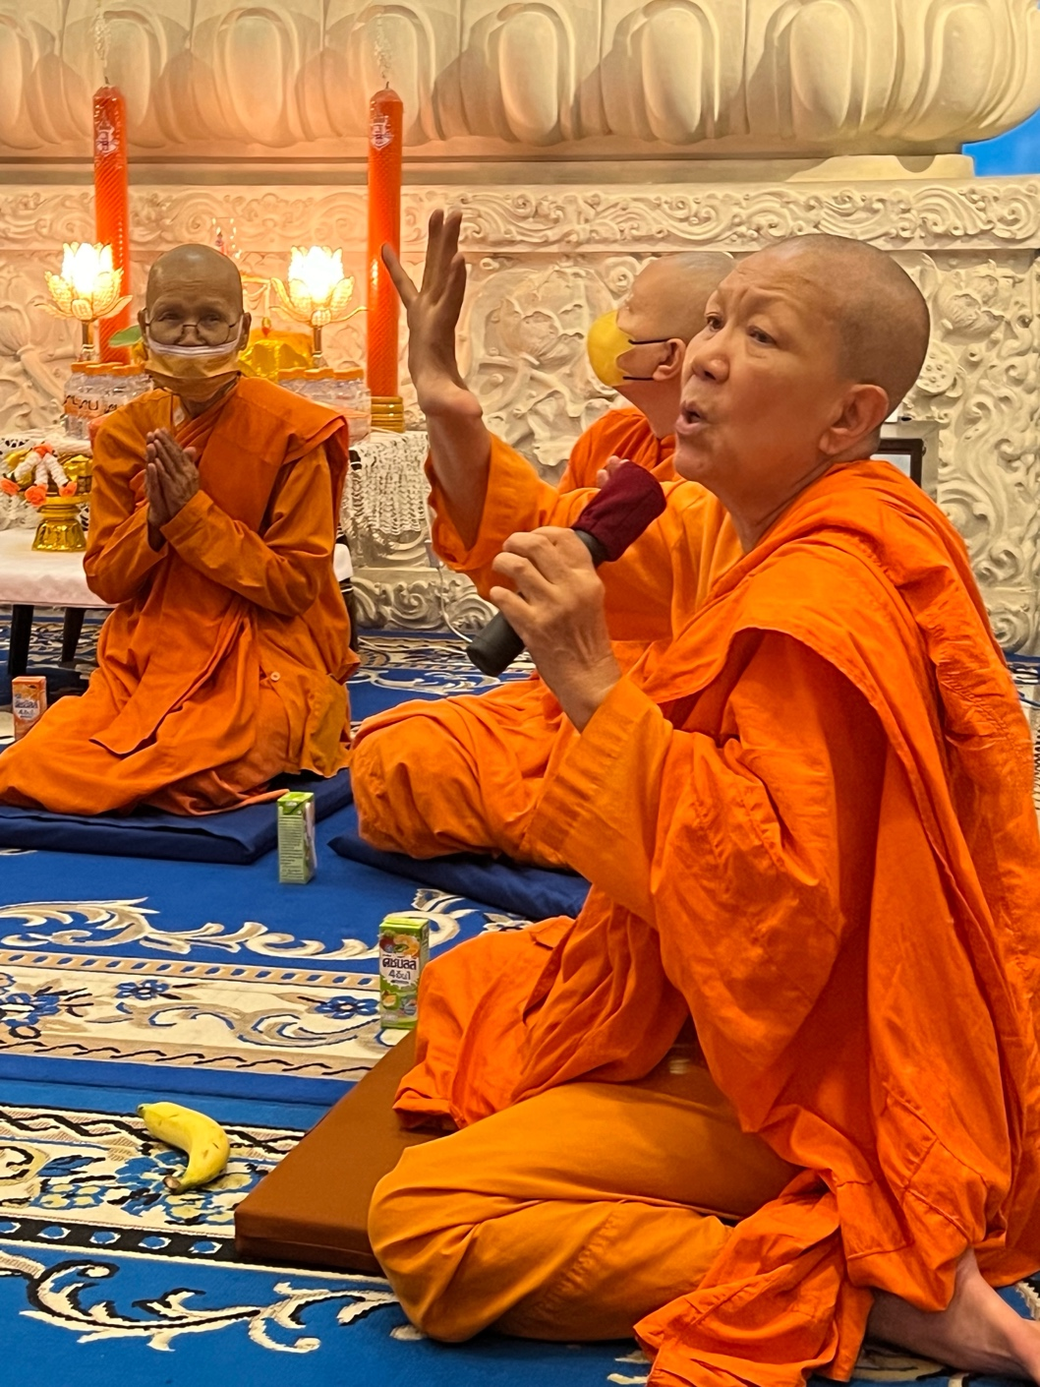

Venerable Dhammananda in the Medicine Buddha Vihara October 2023
Photo by Cindy Rasicot

